

**java project**



Kruger Maxence

Hoyez Alexis

Boogaerts Paul

Naessens Valentin

**Summary :**

I/ Context 2

II/ The Project 4

A- Diagrams 4

**1. Class Diagram 4**

**2. Package Diagram 6**

**3. Sequence Diagram 7**

**4. Component Diagram 7**

B- Code 8

III/ Conclusion 9

A- General overview 9

B- Personnal review 9

C- Prospects for improvement 9

<https://github.com/Paulbgt/Projet-Java>

# I/ Context

In a first part, we have to acquaint with the subject, we have to create a video game : « Boulder Dash »

The hero « Rockford » have to dig in order to find many diamond to spend a level.

The goal is to work in groupe to realize the game on two weeks.

This game have many constraints :

* Monsters : They can move, kill the hero
* Dirt : Who can be destroyed by the hero
* Wall : This is on the floor but can’t interact with something
* Stone : The stone can move, kill the hero and the monsters but when the hero do nothing, it stay immobile.
* Diamond : It can be taken by the hero, he can kill the hero and monsters too, and can appear when a monster has been killed.
* Floor/Background : The floor appear when something is broken or when someone has been killed, it’s the thing behind the others (Monsters, Dirt, Wall, Stone, Diamond, Hero). We can see it too when something or someone is moving.
* In fact, the hero can move and dig.

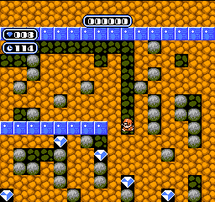

|  |  |  |  |  |  |  |  |
| --- | --- | --- | --- | --- | --- | --- | --- |
|  | Hero | Monster | Dirt | Wall | Stone | Diamond | Floor |
| Hero |  |  |  |  |  |  |  |
| Monster |  |  |  |  |  |  |  |
| Dirt |  |  |  |  |  |  |  |
| Wall |  |  |  |  |  |  |  |
| Stone |  |  |  |  |  |  |  |
| Diamond |  |  |  |  |  |  |  |
| Floor |  |  |  |  |  |  |  |

In our opinion, the situation might be shown with a kind of dependency matrix, in order to show all of the links between the differents elements :

So, we can divide our diagram on 5 big parts:

* First, the Main part where we’ll start the project.
* Secondly, the View part where we put the Jpanel and Jframe, it’s the display part:
* Jframe corresponds to the window in general.
* Jpanel, it displays the score, the game so he “fills” the Jframe.
* Thirdly, the Controller part where we’ll show the orders requested to be executed:
* For example, the things linked by the Keylistener who’ll allow the interaction between keyboard and the video game.
* Fourthly, the contract which allows to put all the interfaces who is an abstract class where methods are abstracts and where attributes are constants.
* At last, the Model, this is the most important part where we can put :
* The differents Objects (Rockford : The Hero, The Monsters, Dirt, Wall, etc…)
* The Map who’ll be load in the Model, Link between database and java.
* The Movements (Monsters, Hero).

Une image contenant capture d’écran

Description générée avec un niveau de confiance élevéOur provisional schedule for this project :

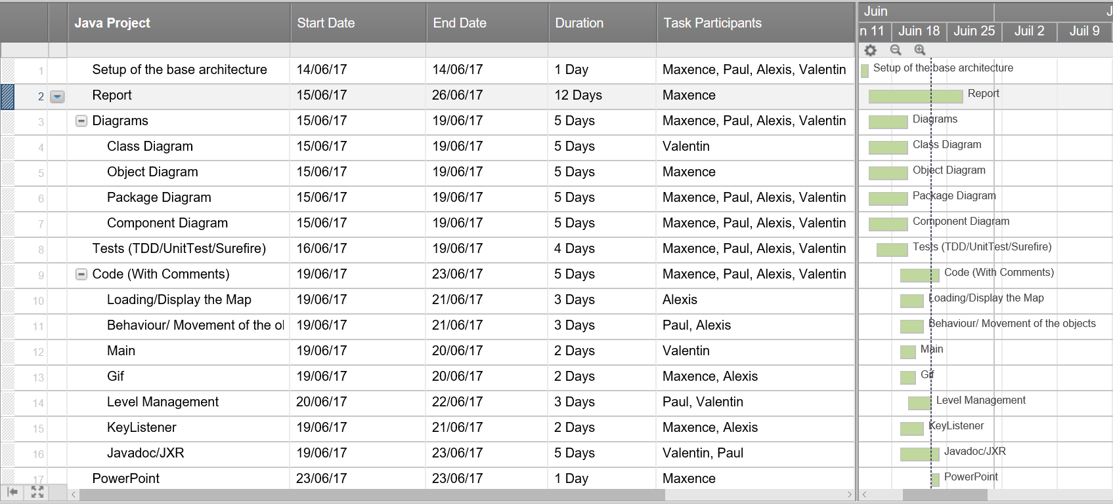Finally we opted for a more detailed diagram :

# 

# II/ The Project

## Diagrams

### Class Diagram

Une image contenant capture d’écran

Description générée avec un niveau de confiance élevé

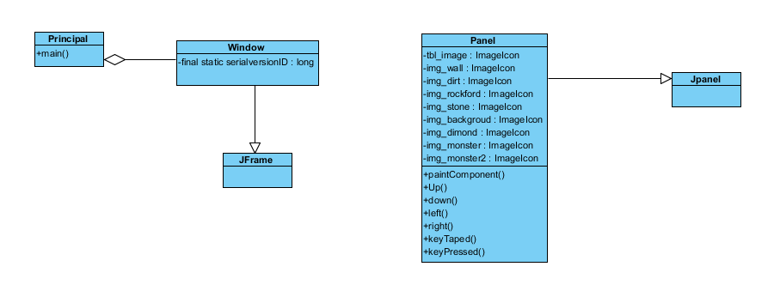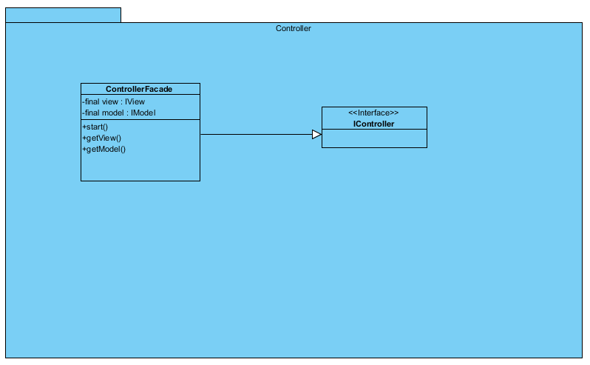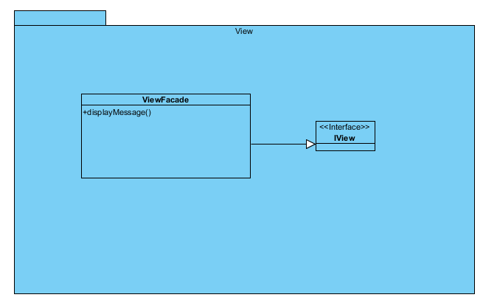

Main

### Une image contenant carte, texte Description générée avec un niveau de confiance très élevéC:\Users\Maxence\AppData\Local\Microsoft\Windows\INetCache\Content.Word\Capture Model entier.pngPackage Diagram

### C:\Users\Maxence\AppData\Local\Microsoft\Windows\INetCache\Content.Word\Capture Sequence.pngSequence Diagram

### Component Diagram

Une image contenant capture d’écran

Description générée avec un niveau de confiance très élevé

## Code

At the beginning of this part we have to know « where are we going ? ».

We need to do a boulderdash in java and to respect the contraints.

When we have established our path for the game we can therefore begin to code:

First, we should do a map. We did it stored in a database, in characters.

Then we can start the code, we must associate the character with the desired picture (Wall, Monsters, Dirt, Hero, etc.…).

After this, one of the most difficult part is to load the map and to reveal the it in the form of pictures.

When we did it, we must insert the movement knowing that the objects have different behaviors, so it’s important to separate them to be able to call them.

The movement and the loading are in the “panel “class.

In our code, we should manage the different behaviors, here is what we have do during this time of project:

* We have several types of monsters, thereby they must act differently.
* The Hero can dig dirt.
* The Hero can die by stone, diamond and monsters (Collision)
* The Hero can’t cross stones and walls but can push stones.
* The Hero can pick up the diamonds.
* Stones and Diamonds can fall.
* When Stones are on Diamonds or other Stones, it falls in an empty adjacent case.
* The Monsters can be killed by Stones or Diamonds when it falls on them.

We have other things to do in our code too, and we did somethings more than what it was requested:

* We must be able to change map, we did it via a menu when we launch boulderdash.
* We have put the gif of Stone, of Diamond to have a more beautiful game.
* The game end when the hero dies and when the diamonds are all picked up.

That explain the results of our project.

To explain our code, we have done a javadoc who explain our methods in GitHub.

# III/ Conclusion

## General overview

Good group overall, each member was very involved in the project, everyone was productive and very good results despite the expectations of the designer. The project was interesting, and we had a beautiful group cohesion in contrary to what one might have thought at the outset. The project was concrete and pleasant to realize.

Difficulties : It was difficult for us to use Maven, and some problems with GitHub.

## Personnal review

**Paul :** I found the project interesting despite that I found the part of software engineering a little too big for our first approach to the P.O.O. I have developed my knowledge in Java and software engineering.

**Maxence :** I found the project interesting, i learned a lot of things during this project and I appreciated it in contrary I don’t really like developement. I liked the group cohesion, it was a pleasure to work with them. I can add that the results was great and I enjoyed program in java.

**Alexis :** The project is really interesting, it allowed me to apply and improve the knowledge learned during prosits, but especially during workshops and exercise baskets. The game we need to create requires a lot of knowledge and do several searches on the internet, which I really liked. Moreover, we were rather free in the design of the games, we were free in the choice of sprites, maps, etc ... The group atmosphere was very pleasant which allowed us to move fast and well from the first day.

**Valentin :** The java Project was an experience with positive and negative point. Indeed, I liked this project because the objective, create a game was fun and concrete project. Furthermore, the ambience in the group was better than I think at the beginning. Moreover, I think use so much genius software was a bad idea, we practice java since a month ago so we are not very strong and it was too hard to mix the different logical with our level. I think it will better to practice some less in this project to be very comfortable with and see the other in an other years.

## Prospects for improvement

Improve the MVC and the Unit Test.